ASSIGNMENT - 2

**PERSONAL EXPENSE TRACKER APPLICATION**

|  |  |
| --- | --- |
| Assignment Date | 27.09.2022 |
| Student Name | DENISHA PRIYA G |
| Student Roll Number | 312419106023 |
| Maximum Mark | 02 |

1. Run a flask app

Successfully installed flask framework and run an app using flask.

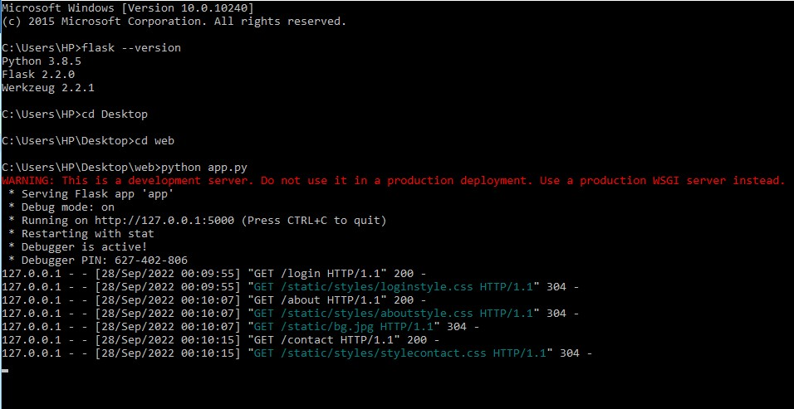

1. Add the home page

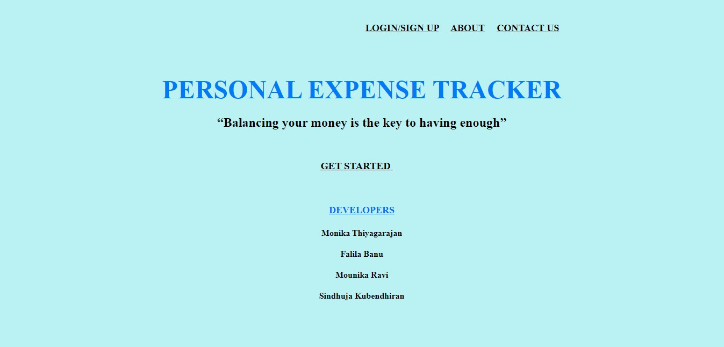

1. Add the login page

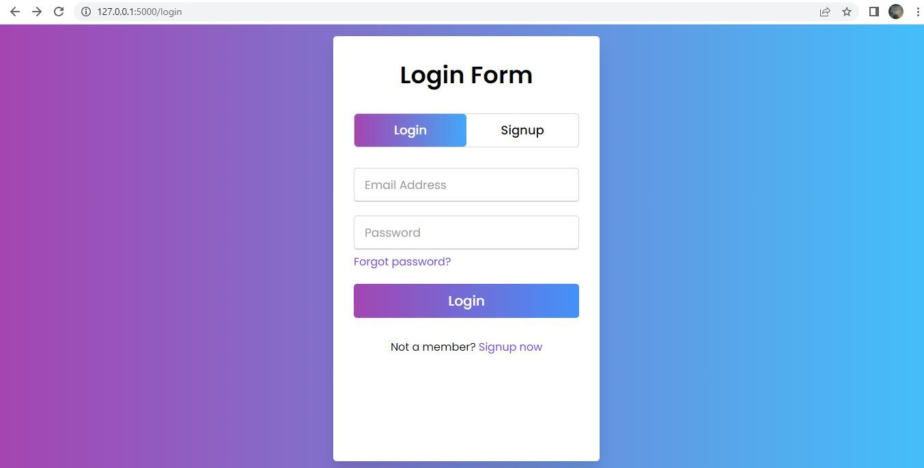

1. Add the Sign up page

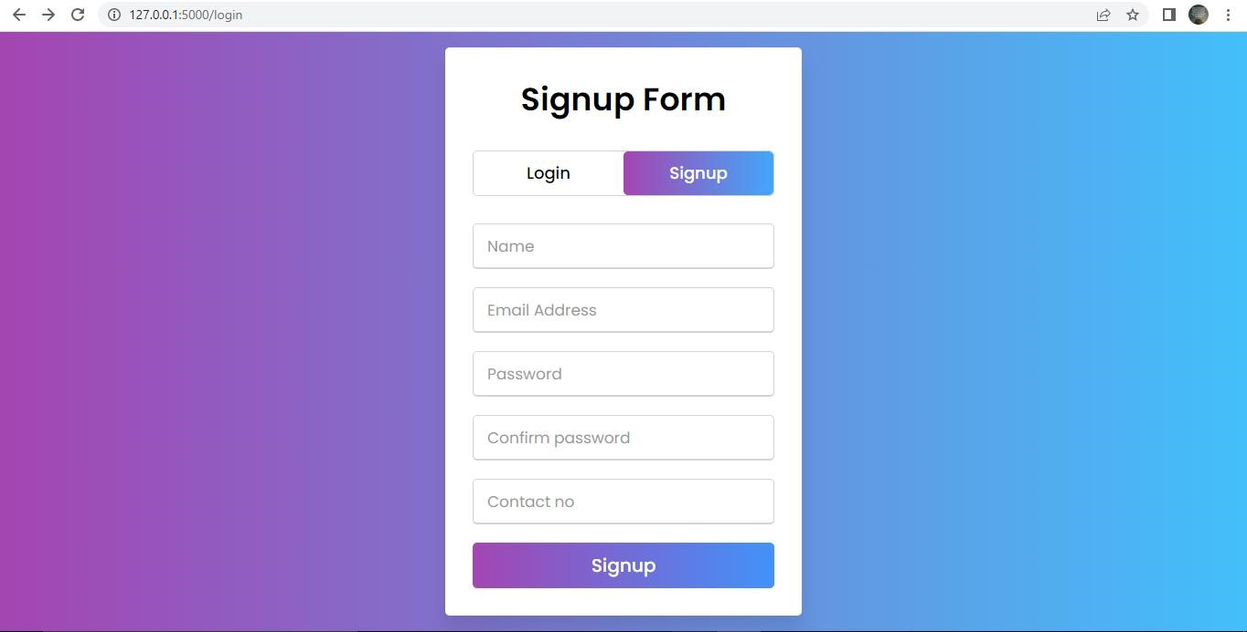

1. Add the contact page

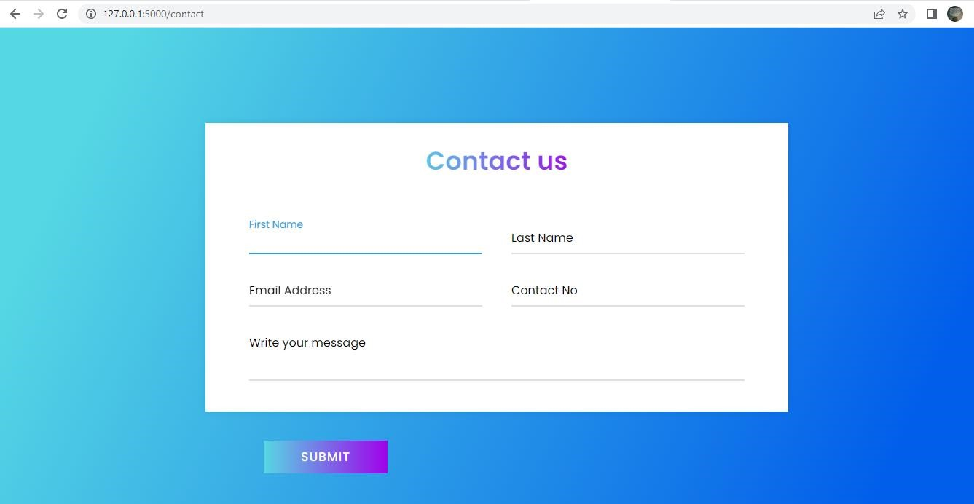

1. Add the about page

